Installation of Ubuntu Linux on Pendrive (USB 3.0 32GB recommended)

Required:

1. Pendrive (Formatted in Fat32)
2. PC with Virtual-box installed. (Download at oracle website)
3. Ubuntu image on your desktop

Steps:

1. Run Oracle Virtual-Box

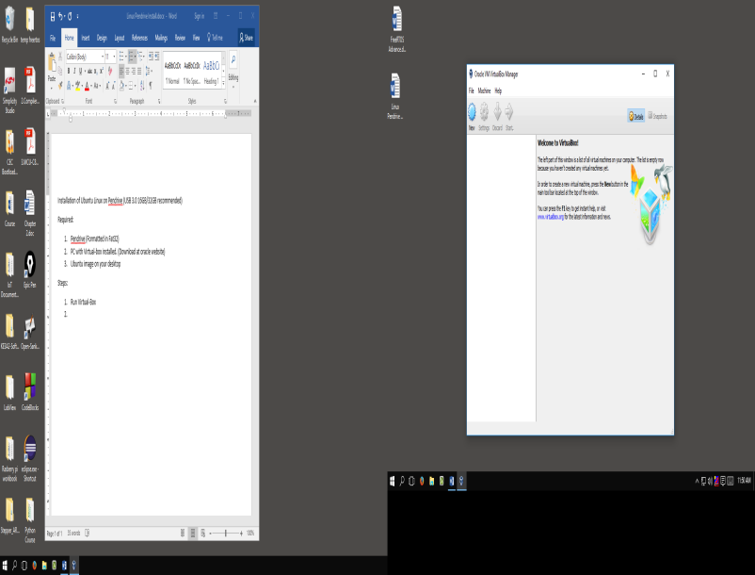

1. Click on **New**. Provide **name** and select Ubuntu **version** (here its **64-bit**). Then Click **Next**.

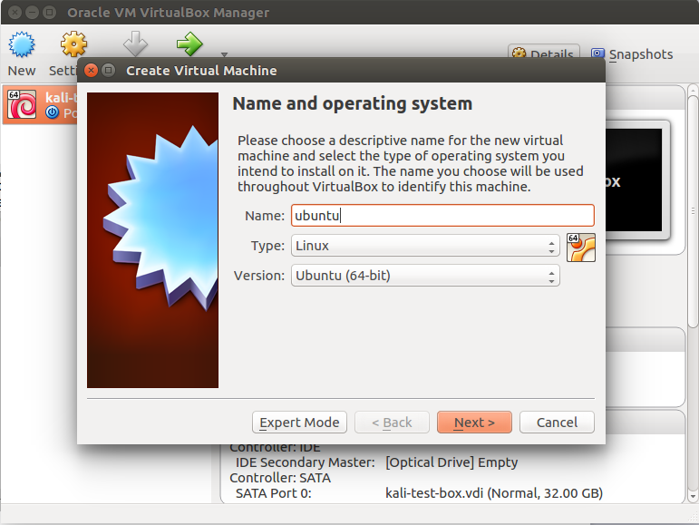

1. Provide sufficient **RAM** **more than 1 GB** if possible (More the ram more the speed of installation). Click **Next**.

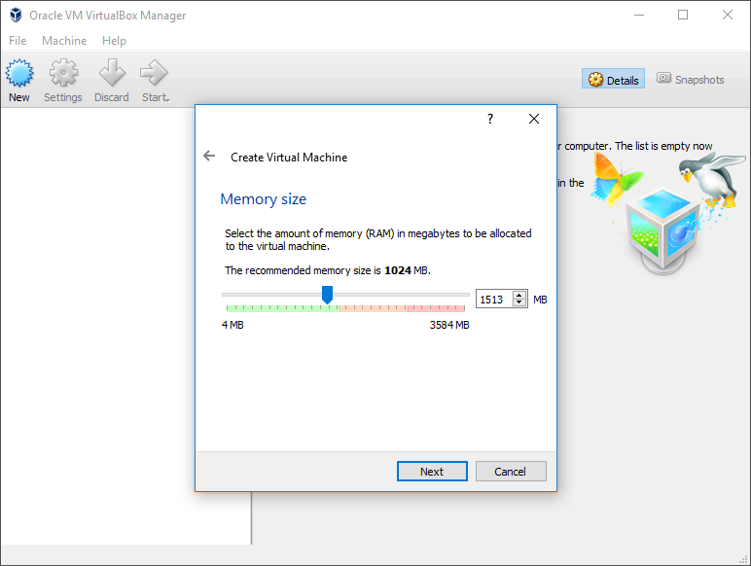

1. Select **Create a virtual hard disk now** and Click **Create**.

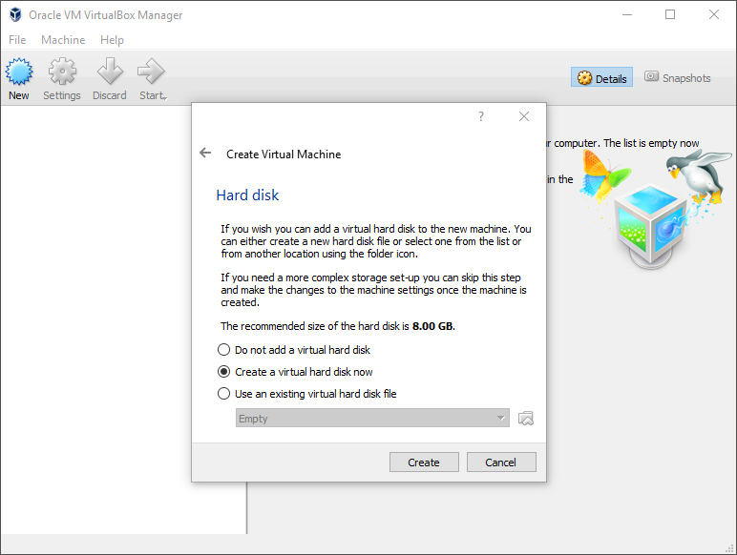

1. Select **VDI (VirtualBox Disk Image)** and Click **Next**. Select **Dynamically Allocated** and click **Next**.

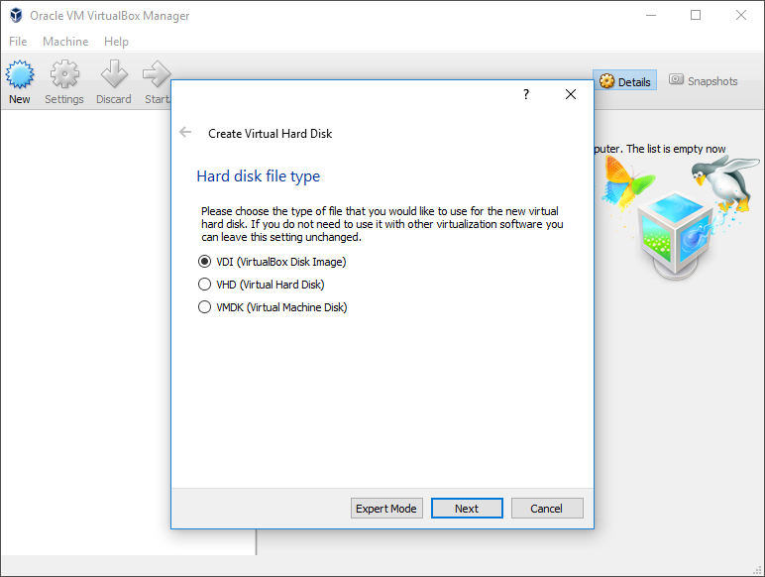

1. Now Provide the size of hard drive. Go with **default** 8 GB as we are not going to install anything in that. Click **Create**.

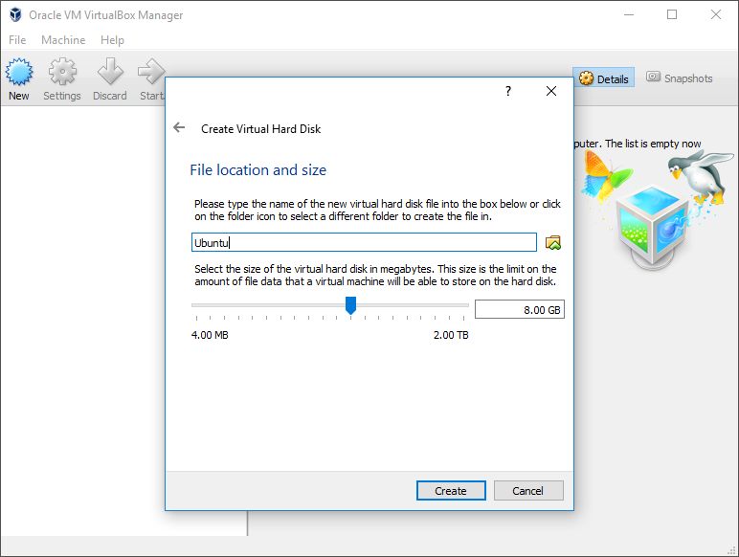

1. Your Screen should look as follows. Now plug your **pendrive** and click on **Settings**.

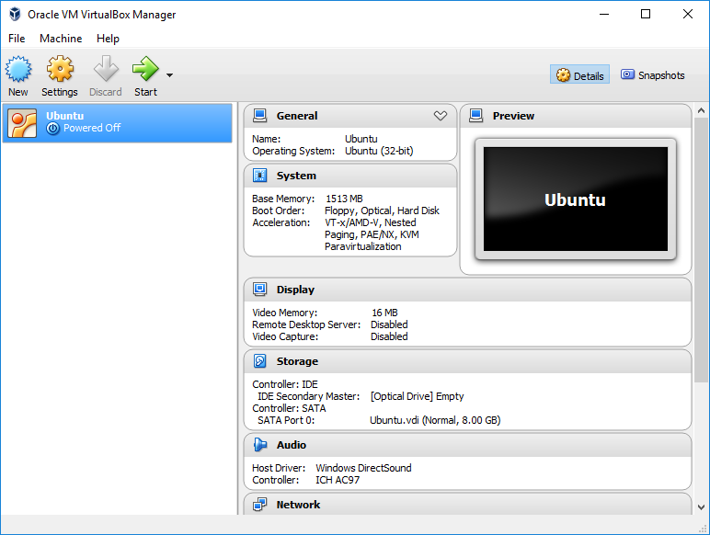

1. Go to **USB** Section in left pane and click on Add USB icon -> Select your **pendrive** from selection (in our case **SanDisk Ultra**). Then click on **OK**.

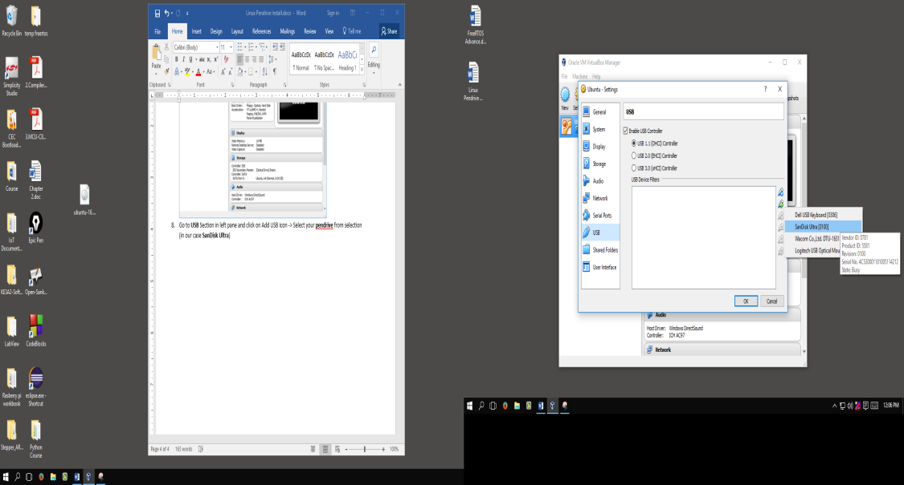

1. Now Click on **Start** to start the virtual Machine.

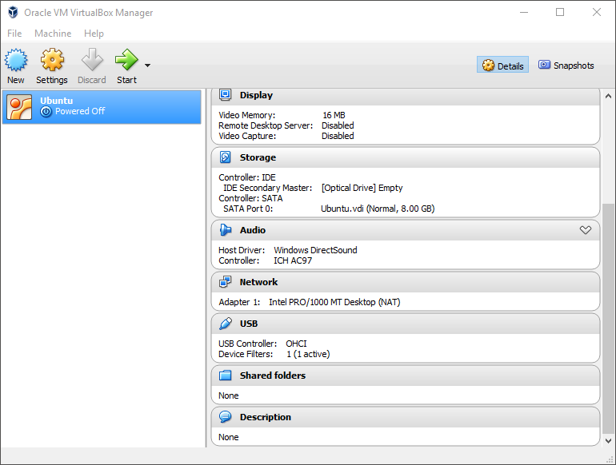

1. First time you run virtual machine it will as for Start-up disk. Here you will provide your Ubuntu image by clicking on **Browse icon**.

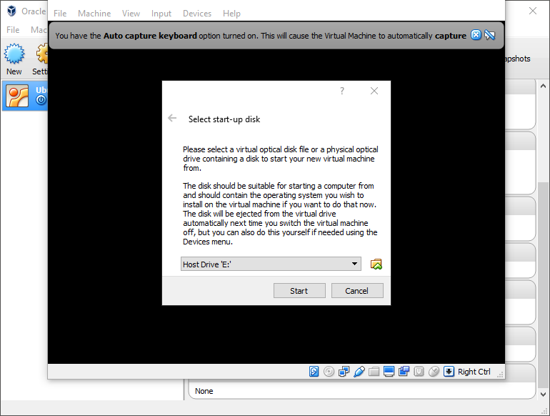

1. Select you **Ubuntu** **image (Any Version)** as shown from your desktop and click **Open**. Then Click **Start** on start-up disk dialog to start booting.

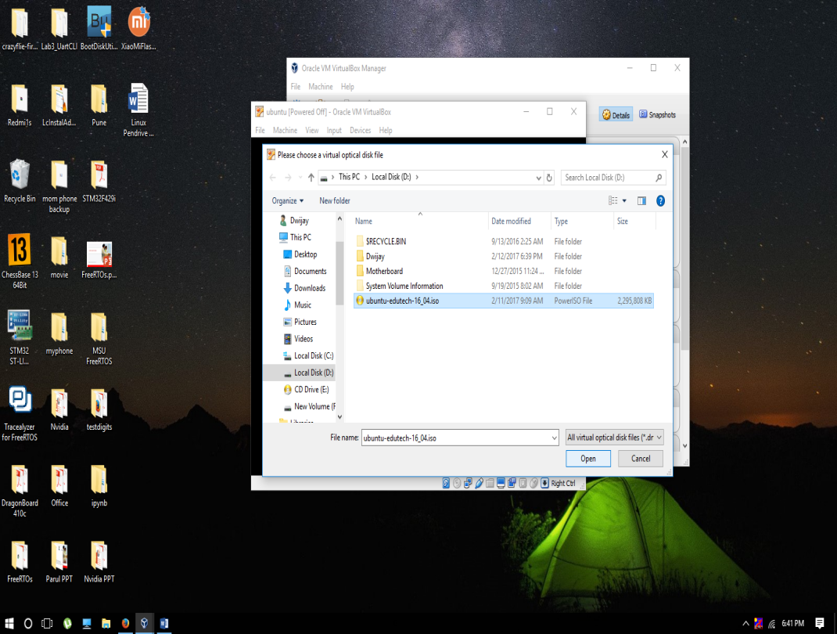

1. Click on **live** in VirtualBox and press **ENTER** key.

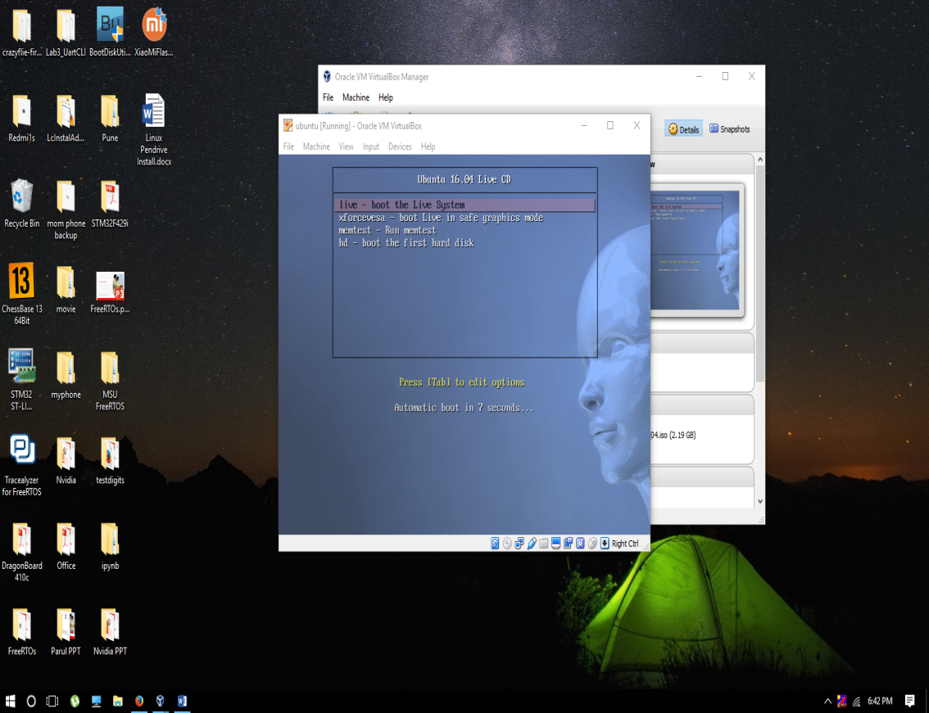

1. Click on user edutech and provide password “edutech” and press enter.

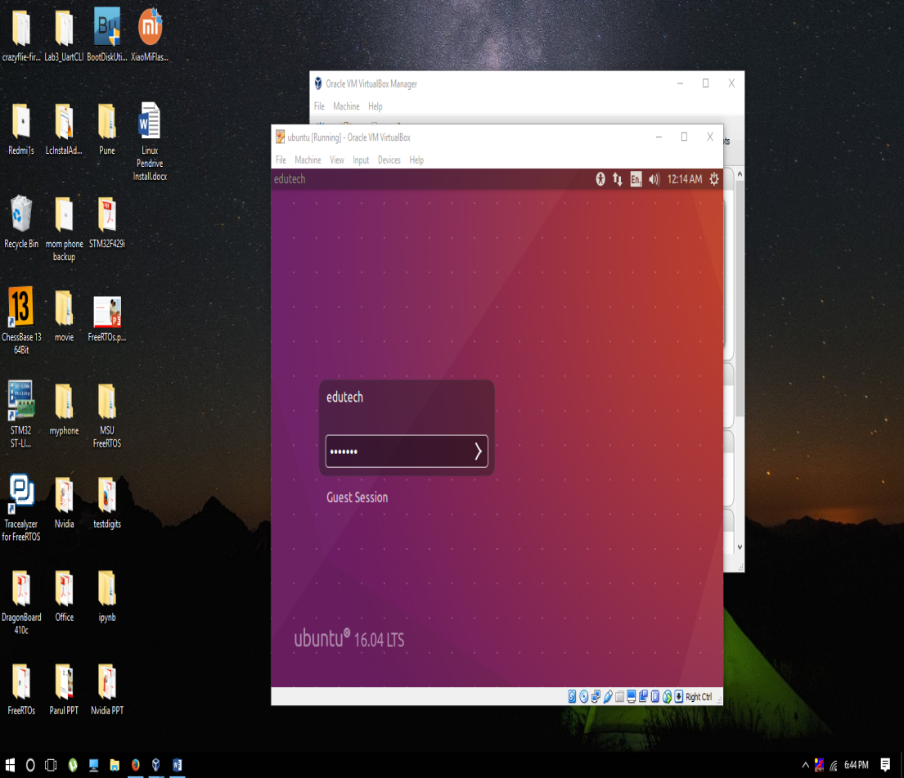

1. Now right click on desktop and select “Open Terminal” from list.

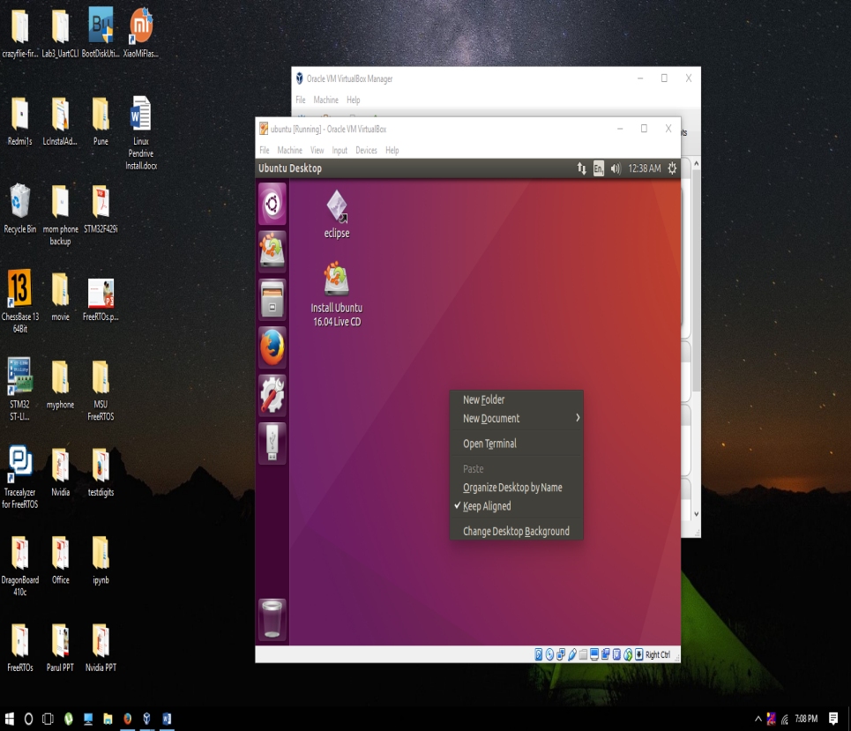

1. Now type following command into terminal and press enter. Then it will ask for password “edutech”.

**sudo ubiquity gtk_ui**

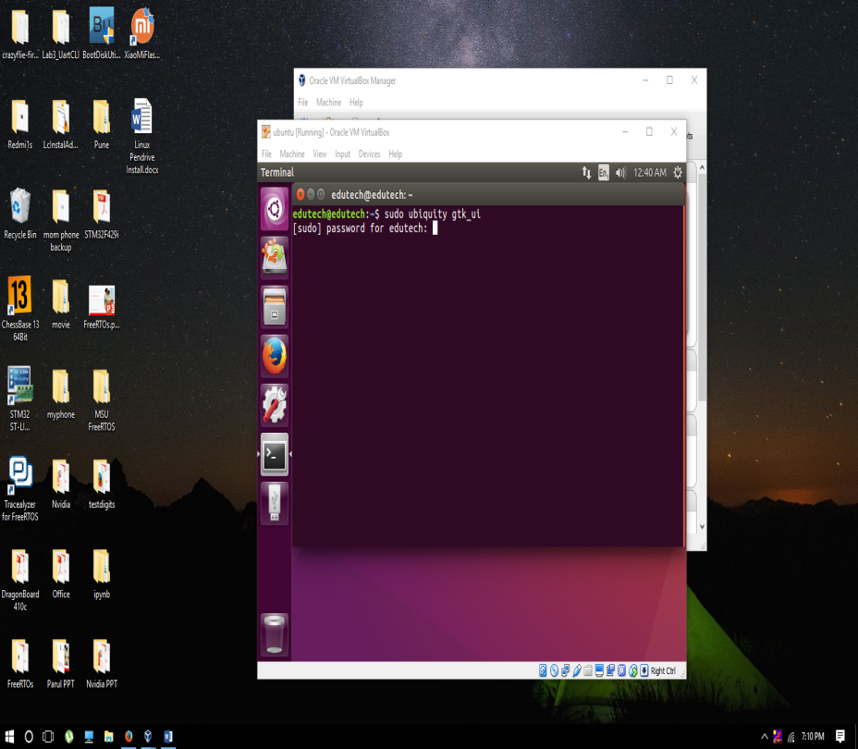

1. It will begin installation wizard as shown. Click on **Continue**.

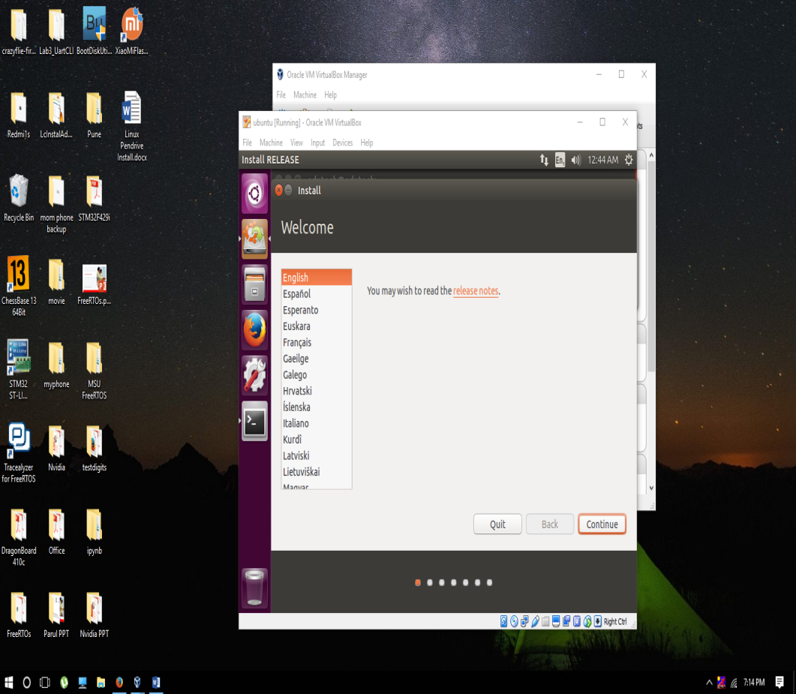

1. Click on **Continue** to proceed with default options.

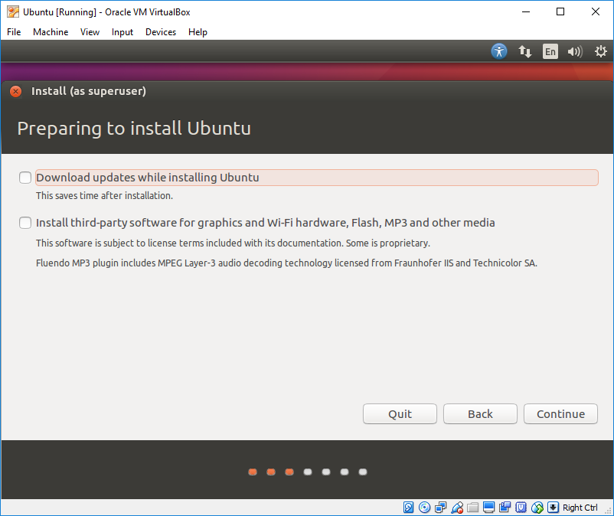

1. It will ask for unmounting the pendrive so it will be able to format and install on it. click on **Yes**.

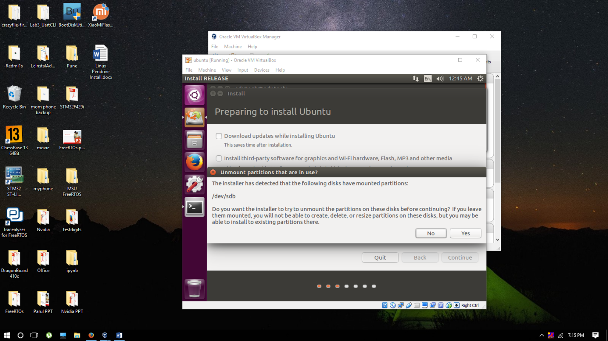

1. Now select **Erase disk and install Ubuntu** and click on **Continue**.

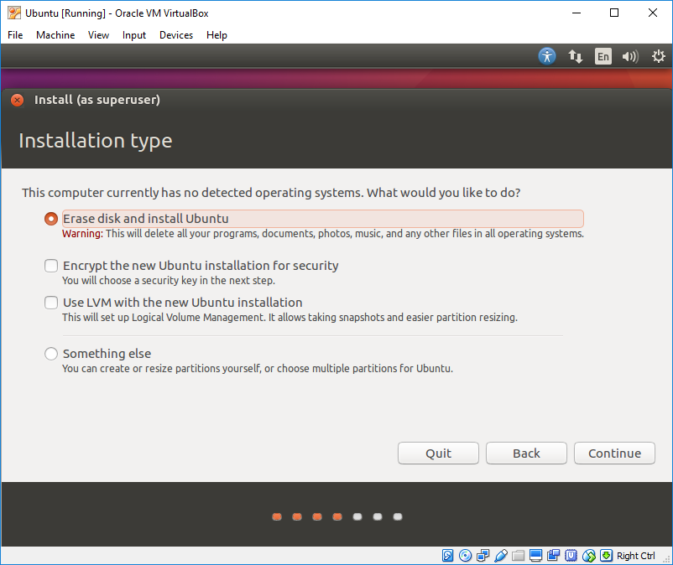

1. This is important step select your **pendrive(SanDisk Ultra)** from selection in drive selection. Click on **Install Now**.

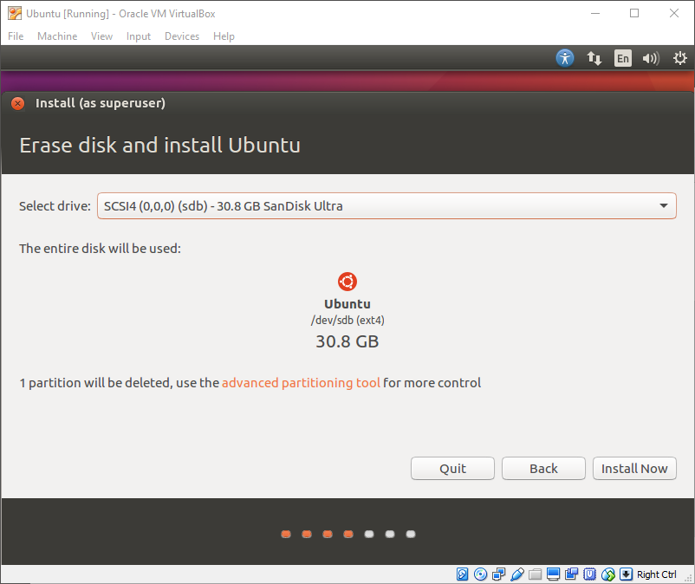

1. Click on **Continue** to write changes on your disk.

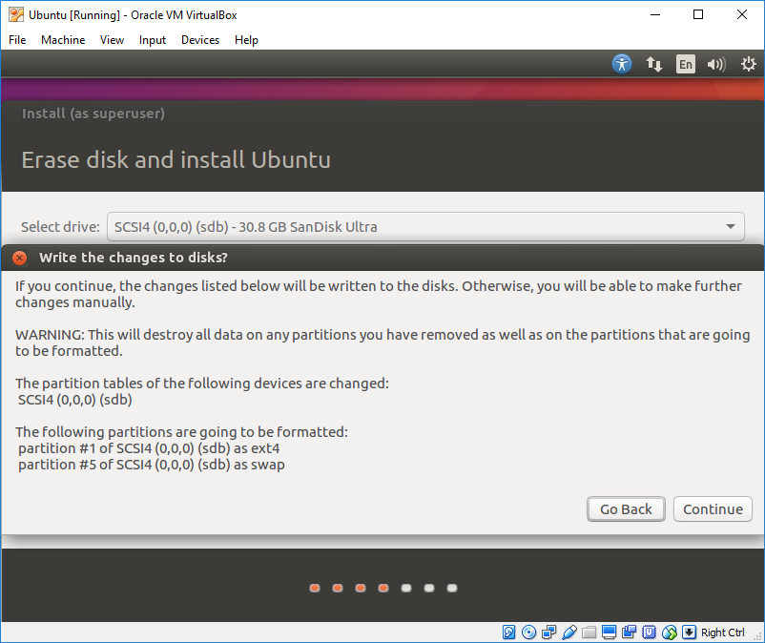

1. Select Country from Map and click **Continue**.

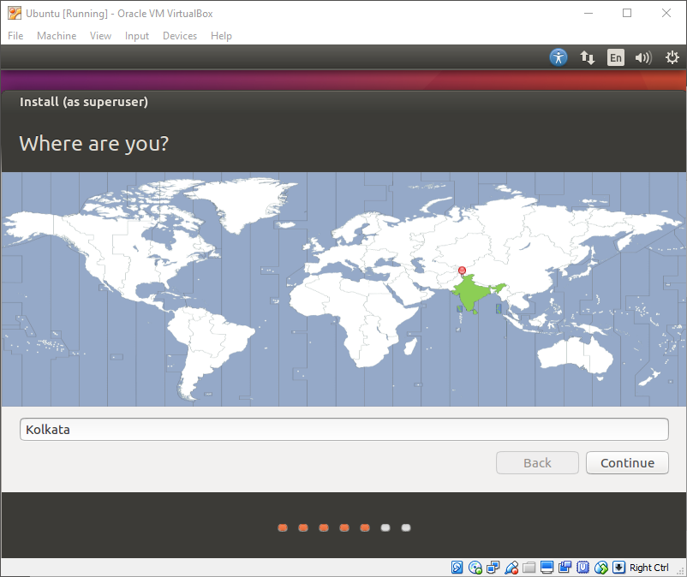

1. Click on **Continue** to proceed with default keyboard layout.

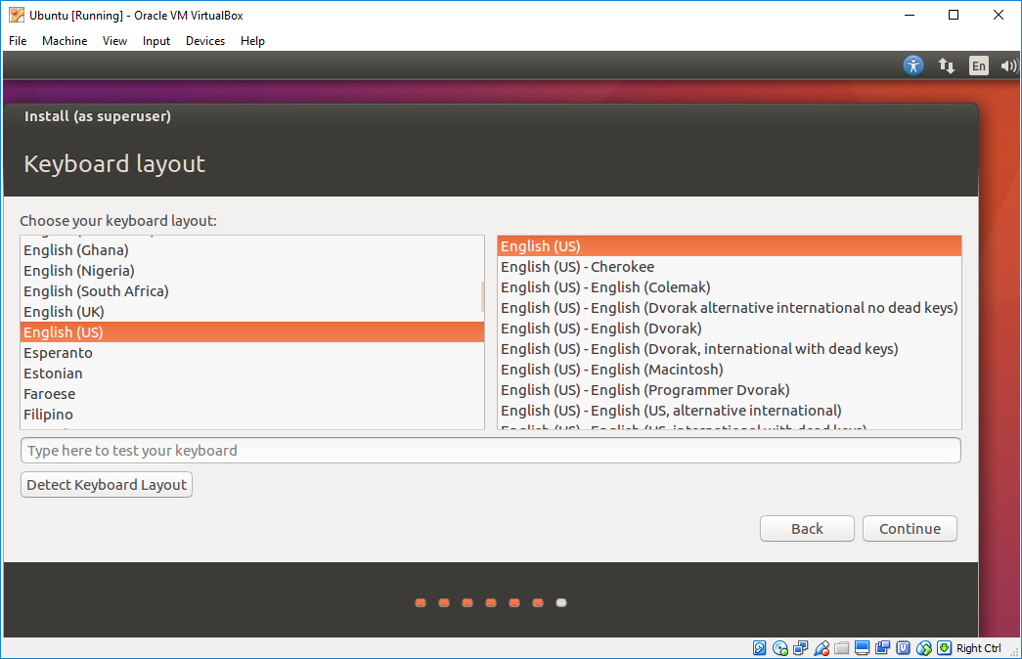

1. Provide any user **name**, then provide any **password** and click on **Continue**.

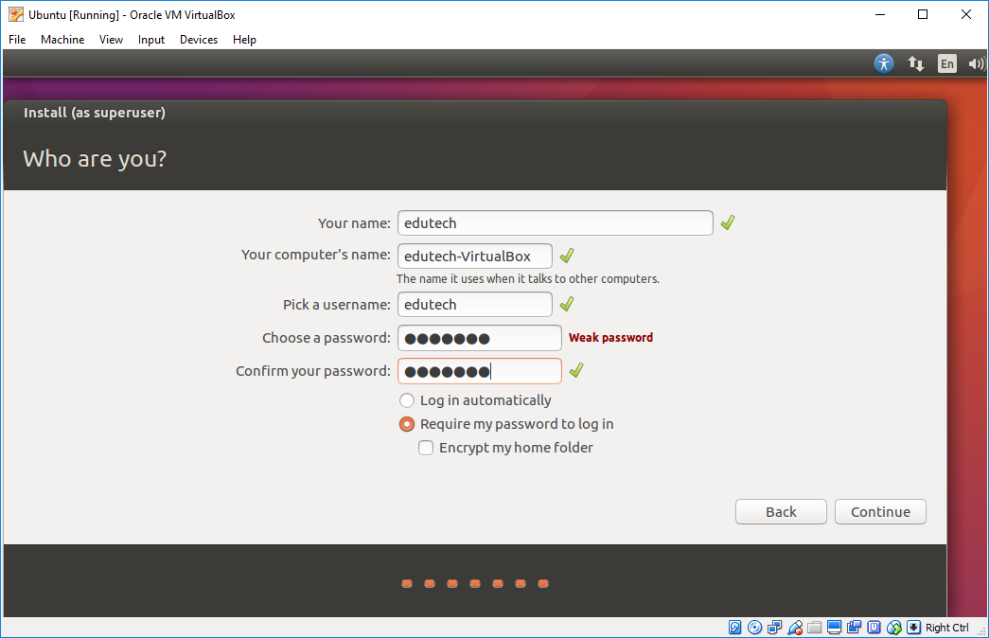

1. This will begin the installation. Now patiently wait until the next dialog box appears.

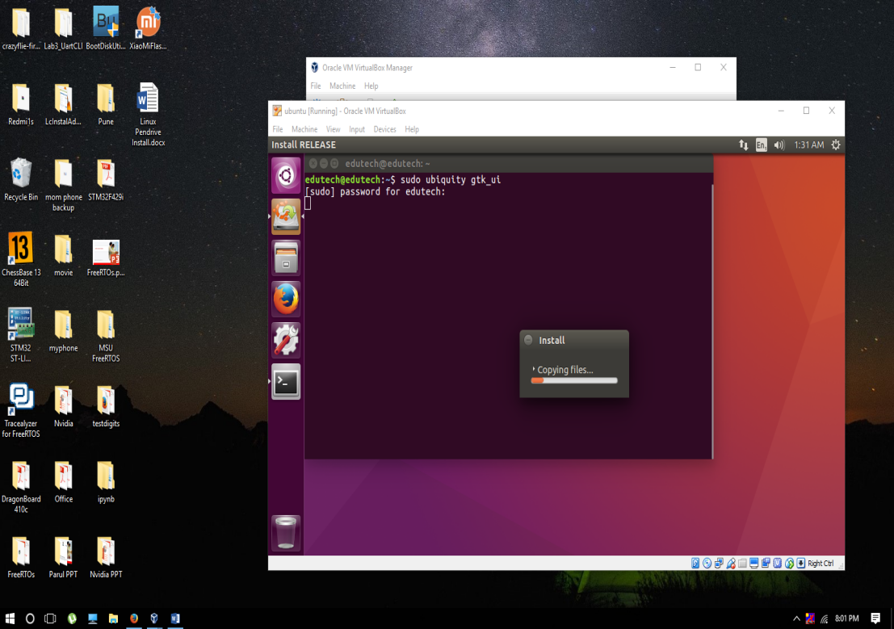

1. Once the installation is complete it will ask for Restart. Click on **Restart Now**. Now Close Virtual Box and Restart PC. Once restarted select pendrive from Boot Option from BIOS.

